**ASSIGNMENT 2 FRONT SHEET**

|  |  |  |  |
| --- | --- | --- | --- |
| **Qualification** | **BTEC Level 5 HND Diploma in Computing** | | |
| **Unit number and title** | Unit 30: Application Development | | |
| **Submission date** | 17/4/2024 | **Date Received 1st submission** |  |
| **Re-submission Date** |  | **Date Received 2nd submission** |  |
| **Student Name** | Truong Viet Dung | **Student ID** | BH00227 |
| **Class** | IT0502 | **Assessor name** | Nguyen Thanh Trieu |
| **Student declaration**  I certify that the assignment submission is entirely my own work and I fully understand the consequences of plagiarism. I understand that making a false declaration is a form of malpractice. | | | |
|  |  | **Student’s signature** | Dung |

**Grading grid**

|  |  |  |  |  |  |  |  |
| --- | --- | --- | --- | --- | --- | --- | --- |
| P4 | P5 | P6 | M3 | M4 | M5 | D2 | D3 |
|  |  |  |  |  |  |  |  |

|  |  |  |
| --- | --- | --- |
| **❒ Summative Feedback: ❒ Resubmission Feedback:** | | |
| **Grade:** | **Assessor Signature:** | **Date:** |
| **Lecturer Signature:** | | |

I. INTRODUCTION 5

II. BODY 6

1. CREATE A FORMAL QUESTIONNAIRE THAT EFFECTIVELY REVIEWS YOUR BUSINESS APPLICATION, PROBLEM DEFINITION STATEMENT, PROPOSED SOLUTION AND DEVELOPMENT STRATEGY. USE THIS QUESTIONNAIRE AS PART OF A PEER-REVIEW AND DOCUMENT ANY FEEDBACK GIVEN(P4) 6

1.1. Formal questionnaire. 6

1.2. Admin 8

1.3. Training staff 10

1.4. Trainer 12

2.1. The result of survey. 13

2.1.1. Personal information. 13

2. DEVELOP A FUNCTIONAL BUSINESS APPLICATION BASED ON A SPECIFIED BUSINESS PROBLEM (P5). 26

2.1. Requirement: 26

2.2. Administrator's Responsibilities: 26

2.3.A training staff’s role: 26

2.4. A trainer’s role: 27

2.5. Administrator ‘s role 27

User Login 27

User Category management 28

User Course management 29

User topic management 31

2.6. Functional System Requirements 32

2.6.1. Administrator Functional Requirements 32

2.6.2. Training Staff Functional Requirements 32

2.6.3. Trainer Functional Requirements 33

2.6.4. Trainee Functional Requirements 33

2.6.5. Comparative Analysis 34

3. REVIEW THE PERFORMANCE OF YOUR BUSINESS APPLICATION AGAINST THE PROBLEM DEFINITION STATEMENT AND INITIAL REQUIREMENTS(P6). 34

3.1. Test Scenario 34

3.1.1. Testing Strategy 34

3.2. Test Case 36

III. CONCLUSION 39

# INTRODUCTION

After the presentation about my design (from Assignment 1), I need to create a formal questionnaire that effectively reviews my business application, problem definition statement, proposed solution, and development strategy. This formal questionnaire should be answered by my colleagues. For any new insights, ideas, or potential improvements to my system, I need to evaluate and justify the reasons why I have chosen to include (or not to include) them as part of this business application. Based on the feedback of my colleagues, I will amend the design if needed. The next task is to develop the business application based on the design, chosen technologies, and methodology. When the application is fully built and tested, I will review its performance against the Software Requirement Specification, analyze the factors that influence its performance, and use them to undertake a critical review of the design, development, and testing stages of my application. I will conclude my review by reflectively discussing my previously identified risks. I will evaluate the strengths and weaknesses of my business application and fully justify opportunities for improvement and further development.

# BODY

## CREATE A FORMAL QUESTIONNAIRE THAT EFFECTIVELY REVIEWS YOUR BUSINESS APPLICATION, PROBLEM DEFINITION STATEMENT, PROPOSED SOLUTION AND DEVELOPMENT STRATEGY. USE THIS QUESTIONNAIRE AS PART OF A PEER-REVIEW AND DOCUMENT ANY FEEDBACK GIVEN(P4)

### Formal questionnaire.

* A few survey questions about user information:

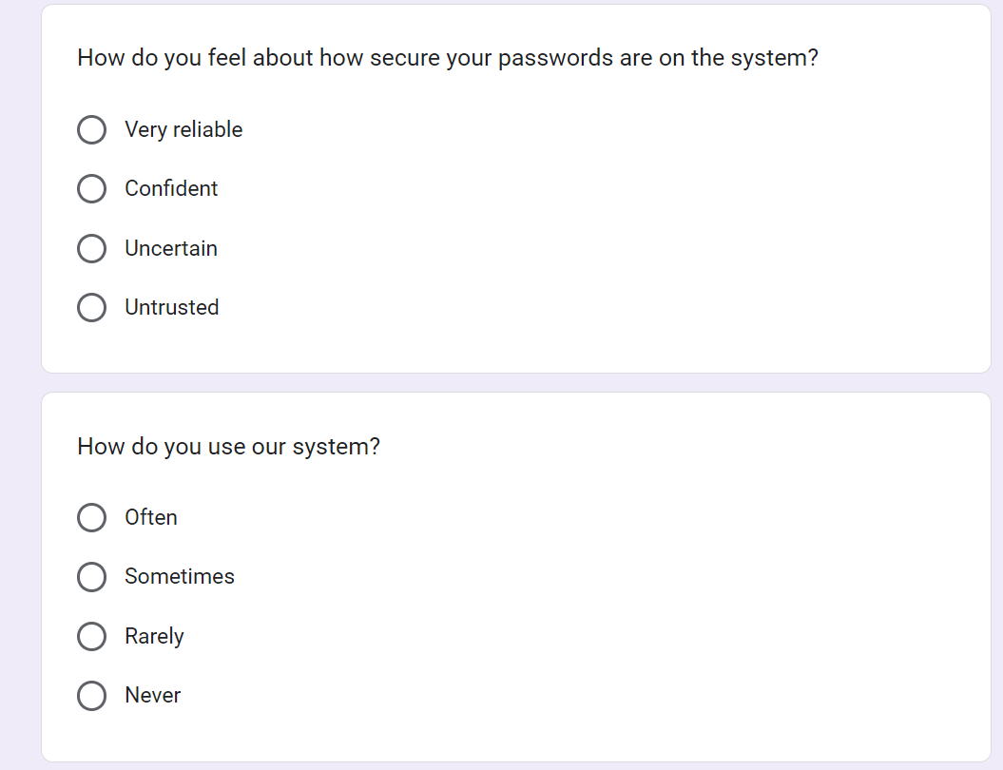

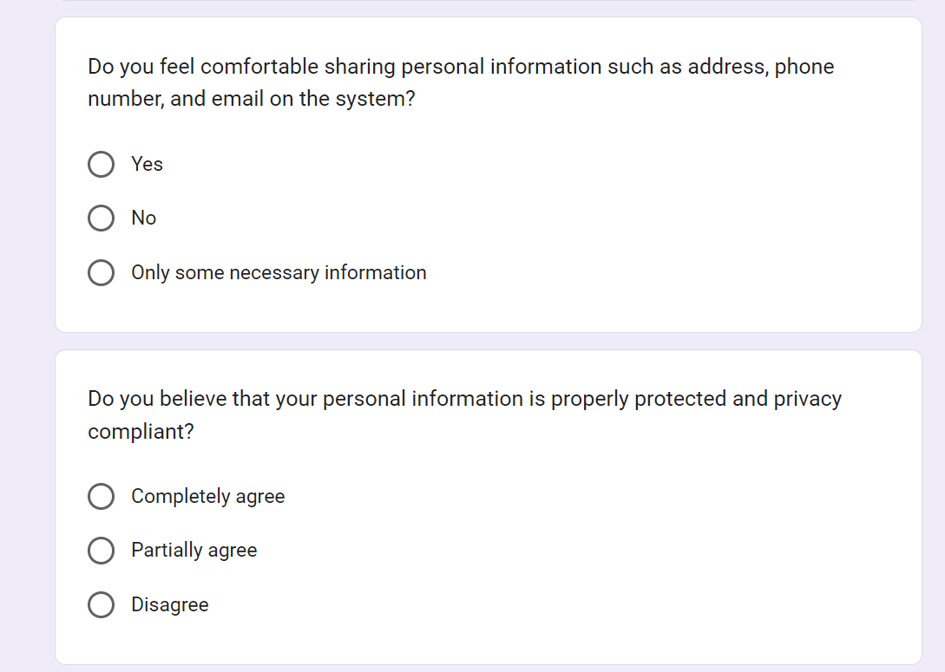

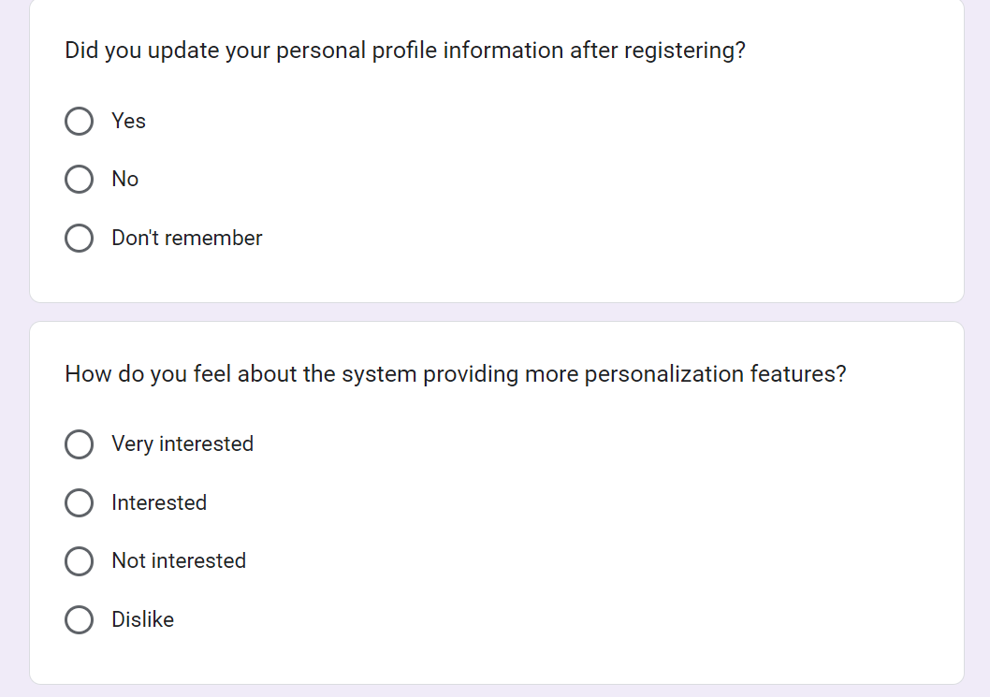

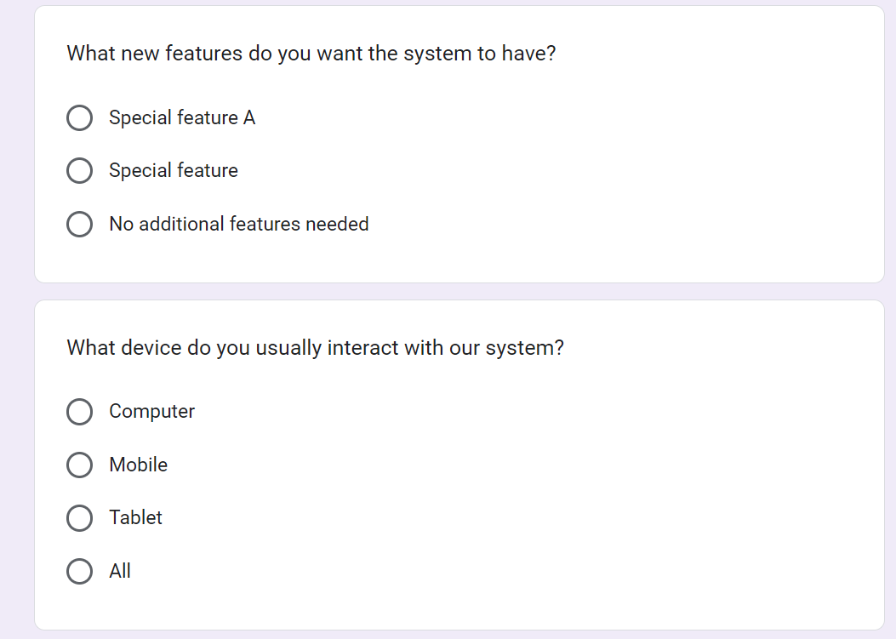

### Admin

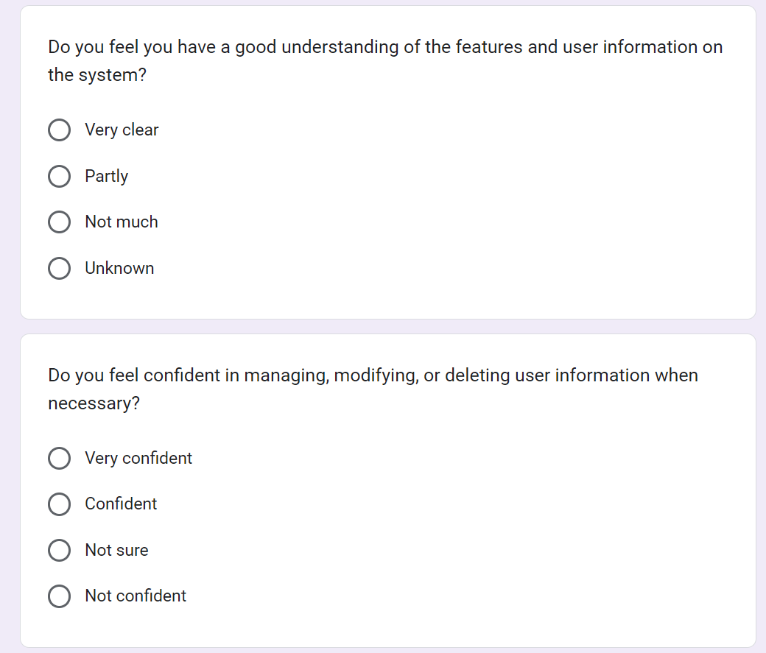

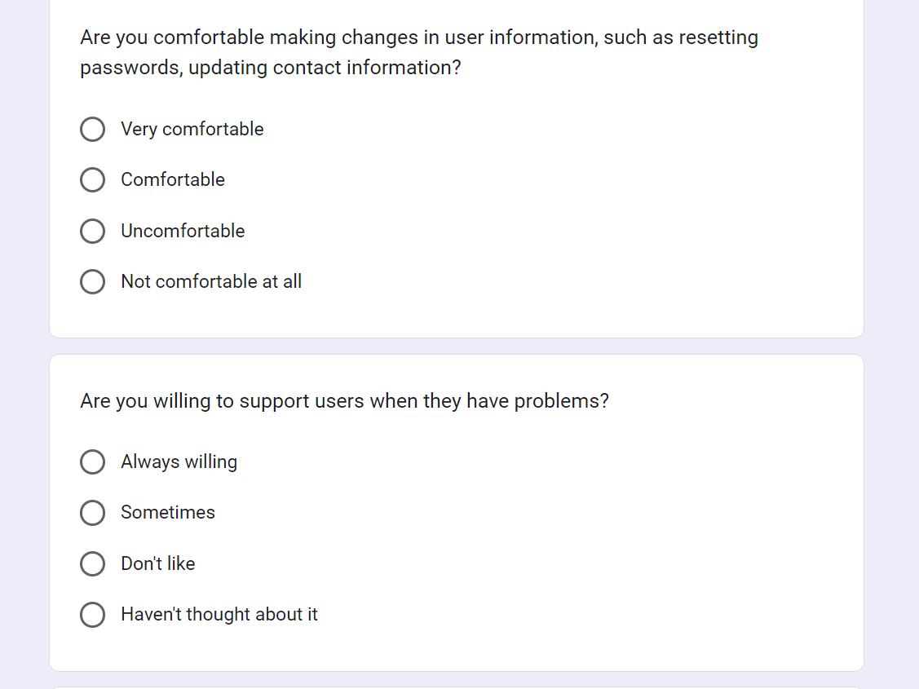

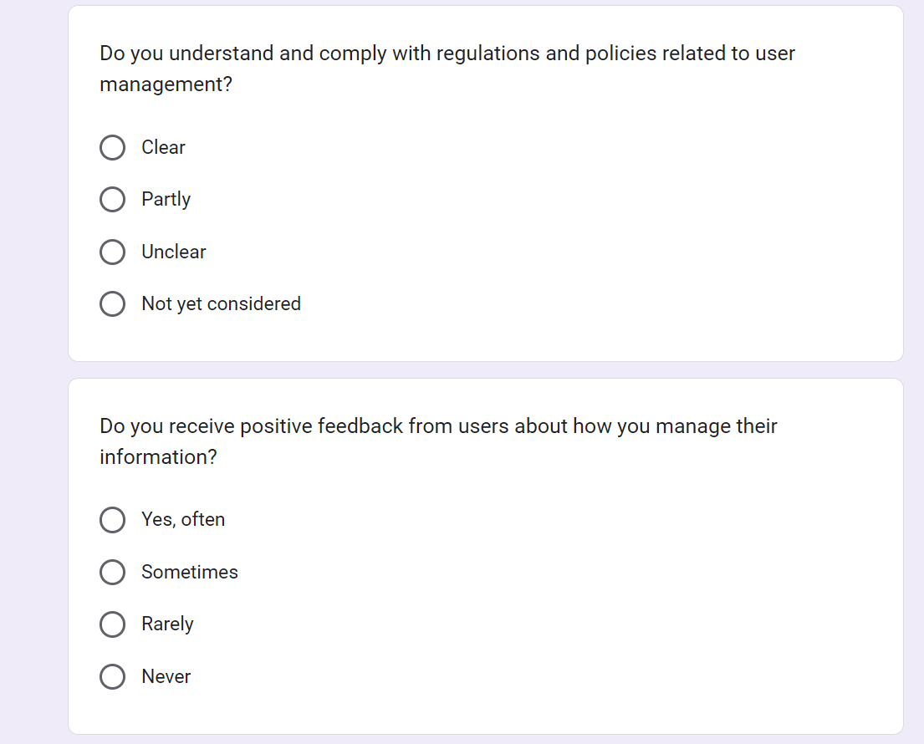

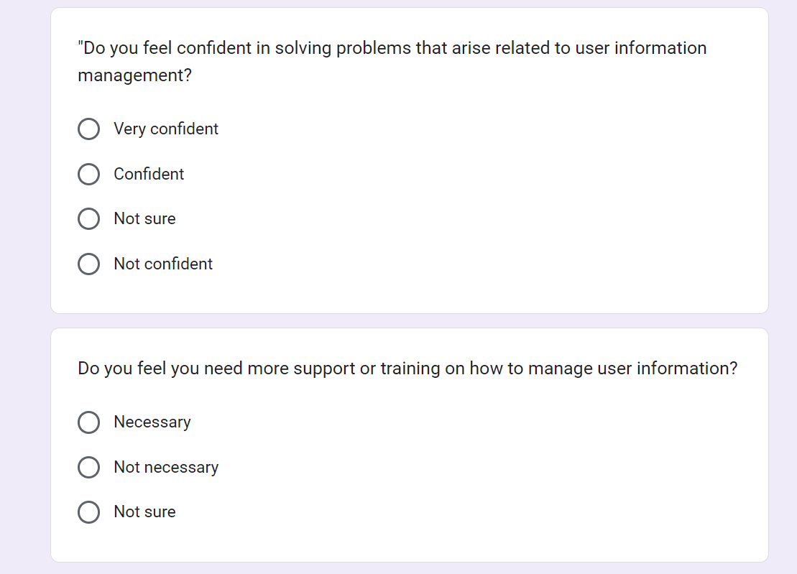

### Training staff

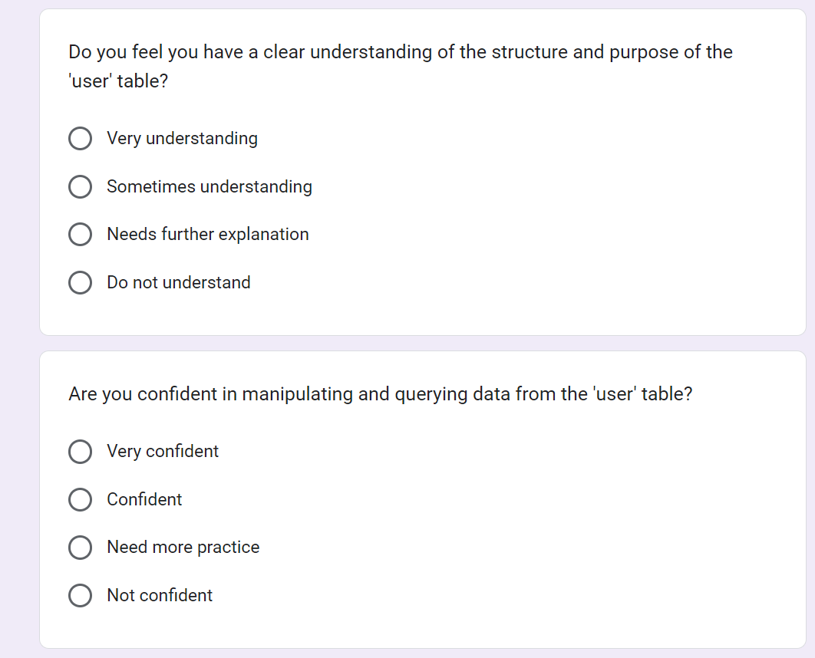

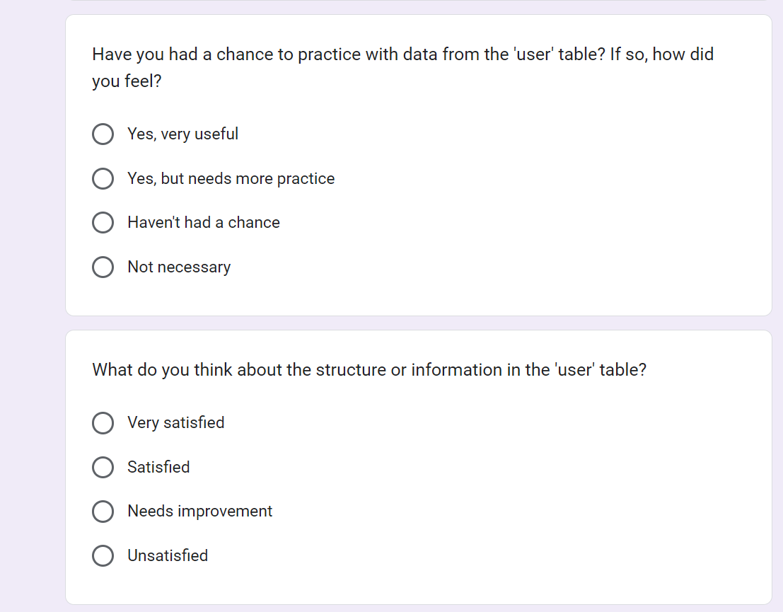

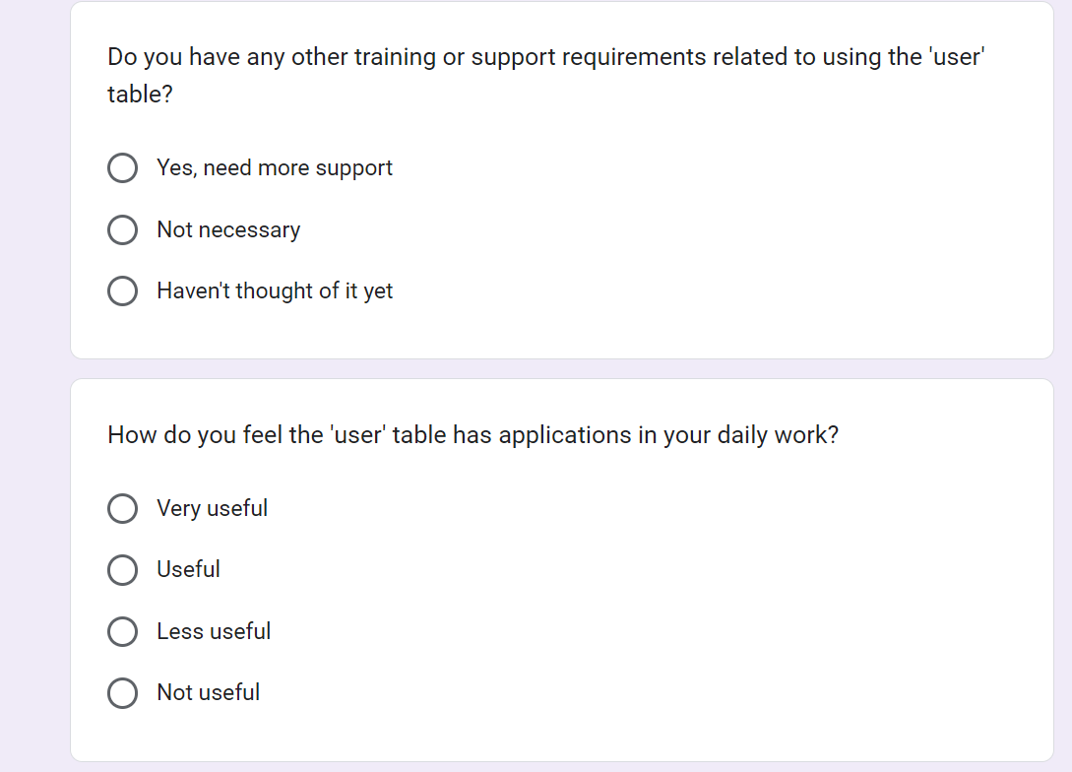

### Trainer

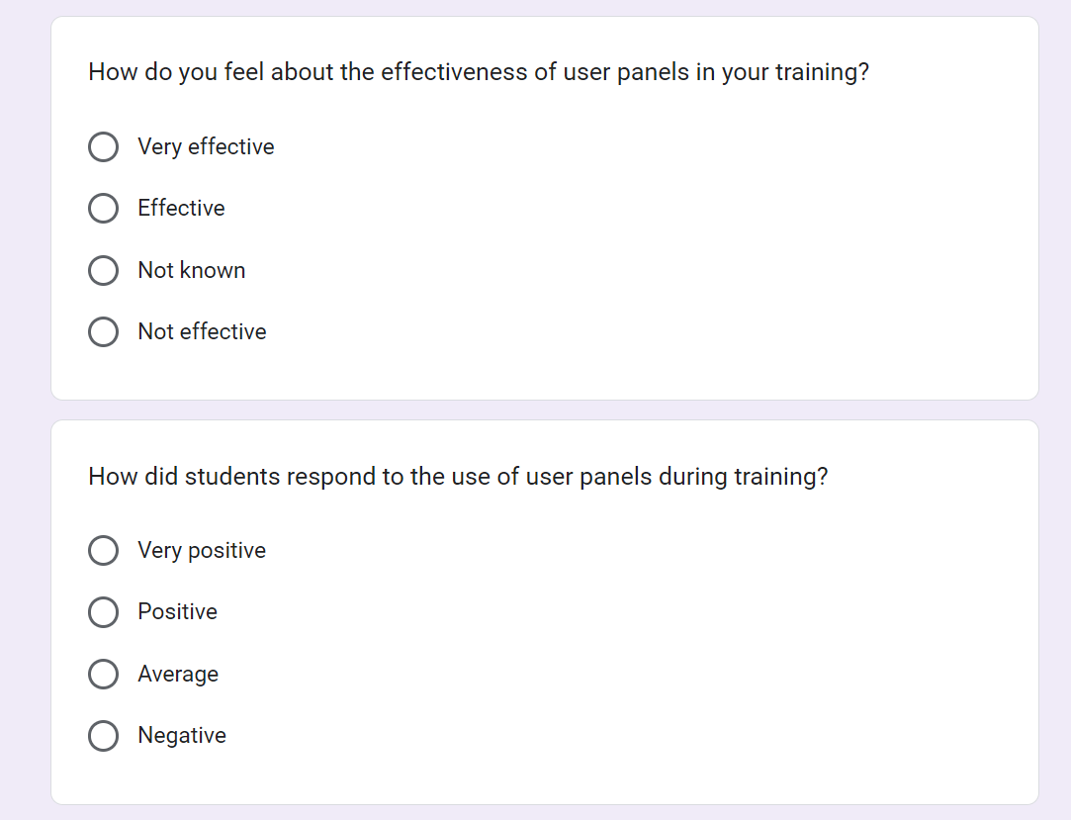

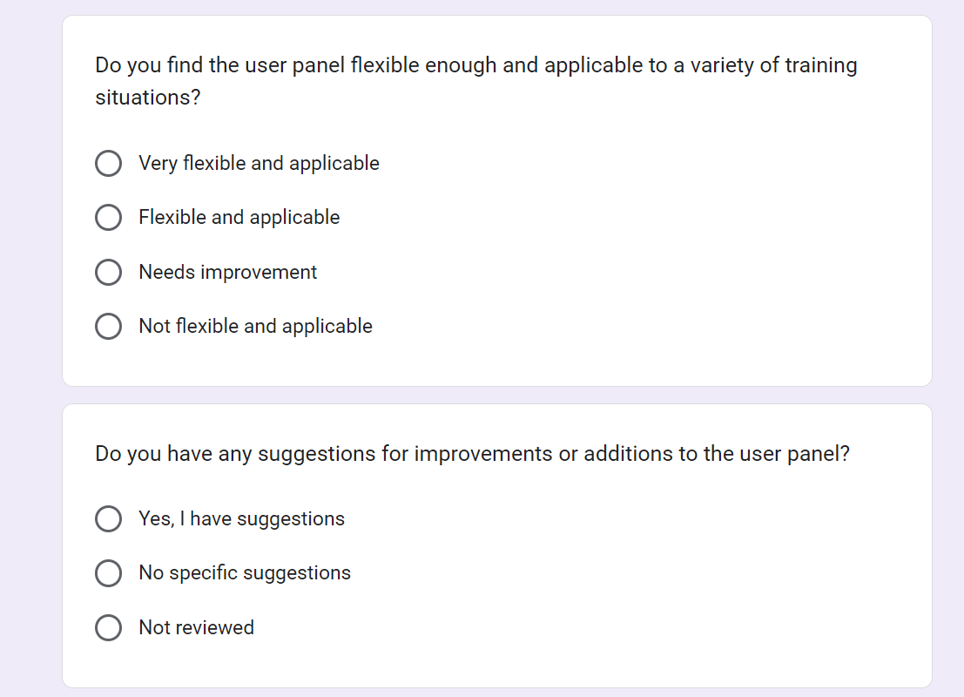

### The result of survey.

#### Personal information.

* How do you feel about how secure your passwords are on the system?

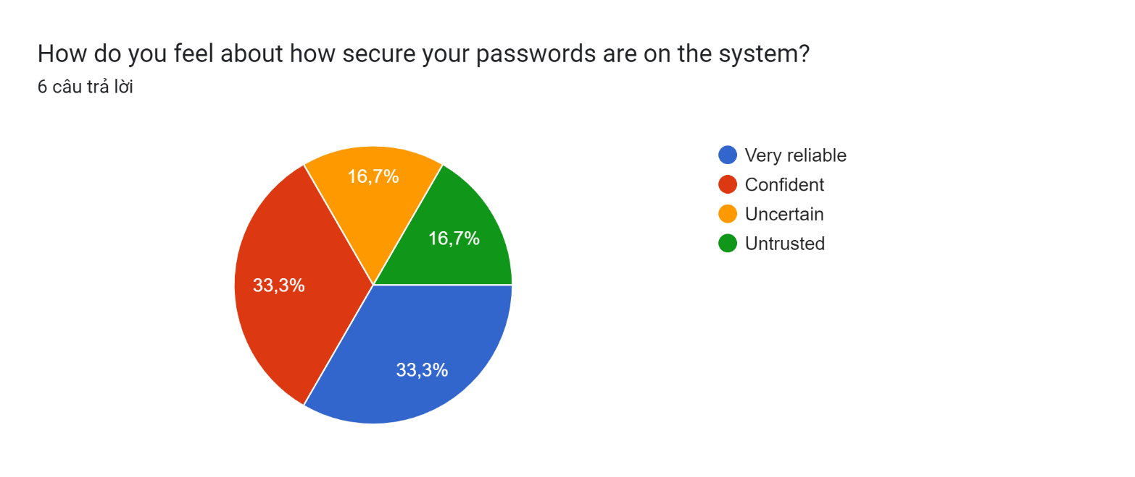

"33.3% Very reliable": 33.3% of users feel that their passwords on the system are very reliable. This may indicate they have high confidence in the security of the system and feel confident about protecting their personal information.

"33.3% Confident": 33.3% of users appear confident about the security of their passwords. Even though they don't feel the password is completely trustworthy, they still have a significant amount of confidence in its security.

"16.7% Uncertain": 16.7% of users feel uncertain about the security level of passwords on the system. This could reflect concerns about the security of the system, or it could be because they need more information or support on how to create stronger passwords.

"16.7% Untrusted": 16.7% of users do not trust the security level of passwords on the system. This can raise concerns about the safety and reliability of the system, and needs to be tested and improved to enhance security.

* How do you use our system?

Biểu đồ câu trả lời của biểu mẫu. Tên câu hỏi: How do you use our system?
. Số lượng câu trả lời: 6 câu trả lời.

- "16.7% Often": 16.7% of users regularly use our system. This may indicate that they are primary users and depend on your system to perform important tasks.

- "50% Sometimes": 50% of users use your system sometimes. This shows they have flexibility in using the system and may not be full users but still seek value from it.

- "16.7% Rarely": 16.7% of users rarely use your system. This may indicate that they do not feel comfortable or needed to use the system, or it may be because they do not see value from using it.

- "16.7% Never": 16.7% of users have never used your system. This may raise questions about the level of awareness and accessibility of the system to this user group, and there is a need to learn more about the causes and how to improve.

* Do you feel comfortable sharing personal information such as address, phone number, and email on the system?

Biểu đồ câu trả lời của biểu mẫu. Tên câu hỏi: Do you feel comfortable sharing personal information such as address, phone number, and email on the system?
. Số lượng câu trả lời: 6 câu trả lời.

33.3% Yes": 33.3% of users feel comfortable sharing personal information such as address, phone number and email on the system. This shows that they trust the security of the system and feel feel secure when sharing your personal information.

"50% No": 50% of users do not feel comfortable sharing personal information on the system. This may reflect concerns about security and privacy, and requires measures to protect personal information and provide clear information about its use.

"16.7% Only some necessary information": 16.7% of users only comfortably share some necessary information on the system. This may suggest that they want to keep their personal information to a minimum on the system and only share the most necessary information.

* Do you believe that your personal information is properly protected and privacy compliant?

Biểu đồ câu trả lời của biểu mẫu. Tên câu hỏi: Do you believe that your personal information is properly protected and privacy compliant?
. Số lượng câu trả lời: 6 câu trả lời.

Based on feedback from users on Google Form, we have the following responses:

- "50% Completely agree": 50% of users completely agree that their personal information is properly protected and complies with privacy regulations. This shows that they trust the security of the system and feel secure about using personal information on it.

- "33.3% Partially agree": 33.3% of users partly agree that their personal information is protected and complies with privacy regulations. This may indicate that although they have confidence in the security of the system, certain concerns or concerns remain.

- "16.7% Disagree": 16.7% of users do not agree that their personal information is protected and complies with privacy regulations. This highlights a serious security and privacy issue on the system and needs to be reviewed and resolved to increase security and trust from users.

* Did you update your personal profile information after registering?

Biểu đồ câu trả lời của biểu mẫu. Tên câu hỏi: Did you update your personal profile information after registering?
. Số lượng câu trả lời: 6 câu trả lời.

- "16.7% Yes": 16.7% of users updated their personal information after registering. This shows that users are proactive and interested in updating their information to ensure that it is always the latest and most accurate information.

- "50% No": 50% of users have not updated their personal information after registering. This may reflect their lack of commitment or lack of interest in updating their personal information, or it may be because they do not realize the importance of doing so.

- "33.3% Don't remember": 33.3% of users do not remember whether they updated their personal information after registering or not. This may reflect a degree of lack of concern or neglect towards the management of personal information on the system.

* Did you update your personal profile information after registering?

Biểu đồ câu trả lời của biểu mẫu. Tên câu hỏi: How do you feel about the system providing more personalization features?
. Số lượng câu trả lời: 6 câu trả lời.

- "0% Very interested": No users are very interested in the system providing more personalization features. This may indicate that there is no great demand on the part of users for more personalization on the system.

- "16.7% Interested": 16.7% of users are interested in the system providing more personalization features. This may indicate that some users appreciate the ability to customize and personalize their experience on the system.

- "50% Not interested": 50% of users are not interested in the system providing more personalization features. This shows that a significant number of users do not need or do not want to use personalization features.

- "33.3% Dislike": 33.3% of users do not like that the system provides more personalization features. This may reflect resistance or dissatisfaction with the integration of personalization features into the system.

* Do you feel you have a good understanding of the features and user information on the system?

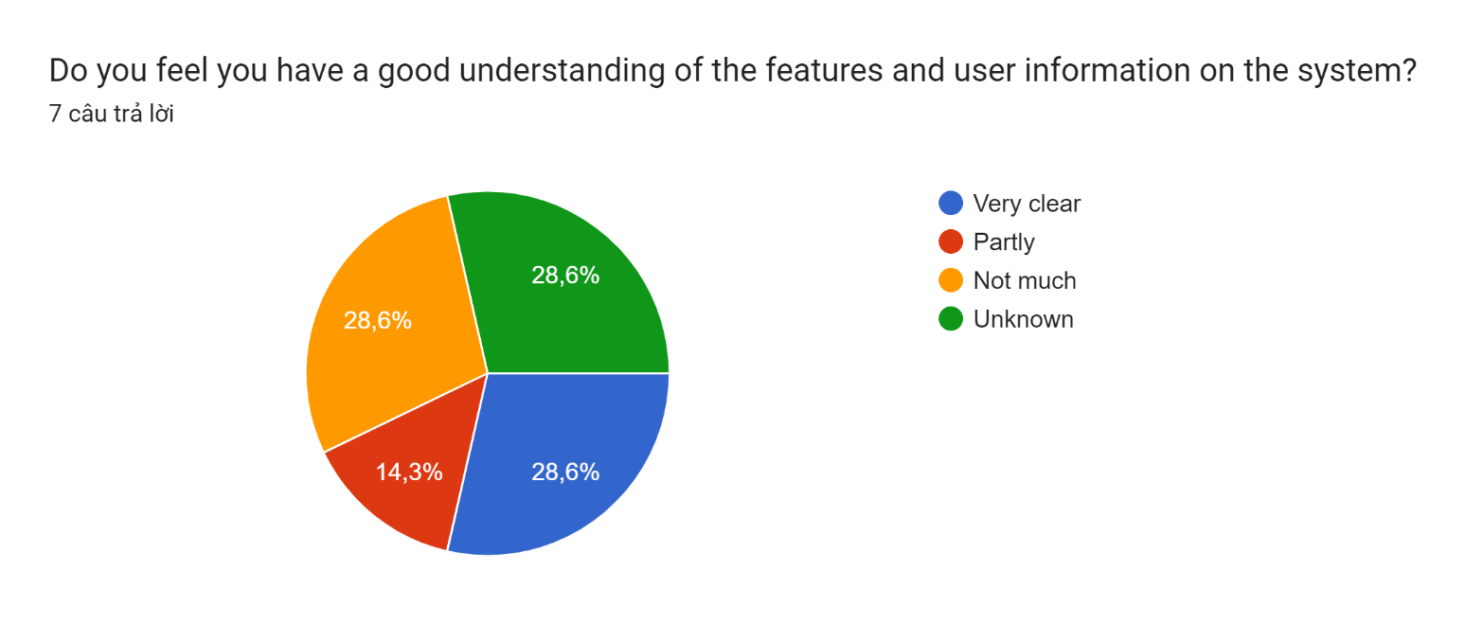

- "28.6% Very clear": 28.6% of users said they have a clear understanding of the features and user information on the system. This shows that a portion of users feel confident and comfortable using the system and understand it well.

- "14.3% Partly": 14.3% of users said they only partially understand the features and user information on the system. This may indicate that some users need additional support or information to better understand the system.

- "28.6% Not much": 28.6% of users said they do not understand much about the features and user information on the system. This may indicate that a large portion of users need additional support or training to understand the system.

- "28.6% Unknown": 28.6% of users said they do not know much about the features and user information on the system. This may reflect a lack of information or awareness of the system on the part of users and the need for increased information and support.

* Do you feel confident in managing, modifying, or deleting user information when necessary?

Biểu đồ câu trả lời của biểu mẫu. Tên câu hỏi: Do you feel confident in managing, modifying, or deleting user information when necessary?
. Số lượng câu trả lời: 7 câu trả lời.

- "14.3% Very confident": 14.3% of users are very confident when managing, modifying or deleting user information when necessary. This shows that a small portion of users feel comfortable and confident in performing user information management operations on the system.

- "28.6% Confident": 28.6% of users are confident when managing, modifying or deleting user information when necessary. This shows that a large majority of users feel confident and comfortable when performing user information management operations.

- "28.6% Not sure": 28.6% of users are not sure about the ability to manage, modify or delete user information when necessary. This may reflect a lack of understanding or confidence in using the management features on the system.

- "28.6% Not confident": 28.6% of users are not confident when managing, modifying or deleting user information when necessary. This shows that some users do not have trust or do not feel comfortable when performing user information management operations.

* Are you comfortable making changes in user information, such as resetting passwords, updating contact information?

Biểu đồ câu trả lời của biểu mẫu. Tên câu hỏi: Are you comfortable making changes in user information, such as resetting passwords, updating contact information?
. Số lượng câu trả lời: 7 câu trả lời.

- "14.3% Very comfortable": 14.3% of users are very comfortable when making changes in user information, such as resetting passwords, updating contact information. This shows that a small portion of users have high confidence and feel comfortable in performing these operations.

- "28.6% Comfortable": 28.6% of users feel comfortable making changes in user information, such as resetting passwords, updating contact information. This shows that a large majority of users have confidence and feel comfortable in performing these operations.

- "28.6% Uncomfortable": 28.6% of users are not comfortable making changes in user information. This may reflect a lack of confidence or experience in managing user information.

- "28.6% Not comfortable at all": 28.6% of users are uncomfortable or not confident when making changes in user information. This suggests that a large portion of users require additional support or training to perform these operations confidently and effectively.

* Do you feel you have a clear understanding of the structure and purpose of the 'user' table?

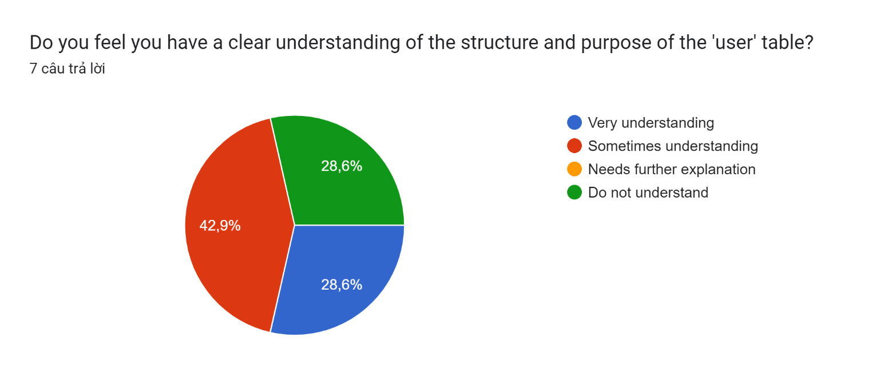

- "28.6% Very understanding": 28.6% of users said they clearly understand the structure and purpose of the 'user' table. This suggests that a small portion of users have a deep understanding and confidence in the structure and purpose of the user table in the system.

- "42.9% Sometimes understand": 42.9% of users sometimes understand the structure and purpose of the 'user' table. This shows that a large portion of users have a fair understanding of the user table, but there may be some aspects or details they need to clarify further.

- "0% Needs further explanation": No users need further explanation about the structure and purpose of the 'user' table. This may indicate that the majority of users understand and are satisfied with the current information about the user table.

- "28.6% Do not understand": 28.6% of users do not understand the structure and purpose of the 'user' table. This may reflect a lack of information or understanding of how the system works on the part of the user, and the need to provide additional information or support.

* Are you confident in manipulating and querying data from the 'user' table?

Biểu đồ câu trả lời của biểu mẫu. Tên câu hỏi: Are you confident in manipulating and querying data from the &apos;user&apos; table?
. Số lượng câu trả lời: 7 câu trả lời.

- "28.6% Very confident": 28.6% of users are very confident in manipulating and querying data from the 'user' table. This suggests that a small portion of users have sufficient knowledge and skills to work effectively with data from the user table.

- "0% Confident": No users are confident in manipulating and querying data from the 'user' table. This may indicate low confidence or a lack of understanding of how to perform data query operations.

- "28.6% Need more practice": 28.6% of users need more practice to be more confident in manipulating and querying data from the 'user' table. This shows that a large portion of users realize their skill level is limited and needs to be improved.

- "42.6% Not confident": 42.6% of users are not confident in manipulating and querying data from the 'user' table. This may reflect a lack of confidence and dissatisfaction with their ability to work with data from user tables.

* Do you find the user panel flexible enough and applicable to a variety of training situations?

Biểu đồ câu trả lời của biểu mẫu. Tên câu hỏi: Do you find the user panel flexible enough and applicable to a variety of training situations?
. Số lượng câu trả lời: 7 câu trả lời.

- "28.6% Very flexible and applicable": 28.6% of users said they felt the user interface was flexible and applicable to many training situations. This shows that a small portion of users appreciate the flexibility and applicability of the user interface in a variety of training situations.

- "57.1% Flexible and applicable": 57.1% of users feel the user interface is flexible and applicable to many training situations. This shows that the majority of users value the flexibility and usability of the user interface in meeting their training needs.

- "0% Needs improvement": No users think the user interface needs improvement. This may indicate that the majority of users are satisfied with the flexibility and applicability of the user interface in training scenarios.

- "14.3% Not flexible and applicable": 14.3% of users feel the user interface is not flexible and not applicable to many training situations. This may reflect their dissatisfaction with the flexibility and usability of the user interface in meeting their training needs.

* Do you have any suggestions for improvements or additions to the user panel?

Biểu đồ câu trả lời của biểu mẫu. Tên câu hỏi: Do you have any suggestions for improvements or additions to the user panel?
. Số lượng câu trả lời: 7 câu trả lời.

- "71.4% Yes, I have suggestions": 71.4% of users have suggestions for improvements or additions to the user interface. This shows that a large portion of users have opinions and wish to contribute to improving the system through suggesting improvements or additions.

- "14.3% No specific suggestions": 14.3% of users have no specific opinions on improvements or additions to the user interface. This may indicate that a small portion of users are satisfied with the current user interface and do not need to change.

- "14.3% Not reviewed": 14.3% of users have not reviewed or have no comments on improvements or additions to the user interface. This may be because they have not had the opportunity or do not want to participate in the feedback process.

## DEVELOP A FUNCTIONAL BUSINESS APPLICATION BASED ON A SPECIFIED BUSINESS PROBLEM (P5).

### Requirement:

In the current era of rapid technological advancement, FPT Co. recognizes the importance of fostering a culture of continuous learning across the organization. To facilitate this, there is a need to develop a web-based system that oversees the training activities within the company. This system will serve as a central hub for managing various aspects of internal training programs. Its functionalities will include the management of trainee accounts, trainers, course categories, courses, topics, as well as the assignment of topics to courses, trainers to topics, and trainees to courses. The Human Resources department will primarily utilize this system.

Within this system, three distinct roles are defined: administrator, training staff, and trainer. Each role carries out specific responsibilities, outlined as follows:

### 2.2. Administrator's Responsibilities:

- Ability to access the system via the initial login page.

- Authority to create, edit, and delete user accounts for trainers and training staff, thus facilitating the management of personnel within the system."

### 2.3.A training staff’s role:

Upon registration, a training staff member is provided with a unique username and password by the administrator. Upon logging in, they are empowered to create trainee accounts by inputting relevant details such as name, age, date of birth, education, primary programming language, TOEIC score, experience, department, location, and more. Once all trainee details are successfully entered, they are securely stored in the database.

The training staff member is equipped with tools to manage trainee accounts, including the ability to update or delete them. Additionally, they can oversee course categories by performing functions such as searching, adding, updating, and deleting categories. These categories encompass essential information such as category name and description.

Furthermore, the training staff member can manage courses by executing similar actions such as searching, adding, updating, and deleting courses. Each course includes pertinent details such as name and description.

They also have the authority to enrich courses by adding topics, including details like topic name and description, and assigning courses to categories.

Moreover, the training staff member is tasked with managing trainer profiles, which involves adding, updating, and deleting information such as trainer name, classification (external or internal), workplace, telephone number, and email address. They can also assign trainers to specific topics and assign trainees to courses.

### 2.4. A trainer’s role:

Within the same system, trainers registered by the administrator can log in to update their profiles, including details such as name, classification (external or internal), education, workplace, telephone number, and email address.

Additionally, trainers have the ability to view courses associated with topics they are assigned to."

### 2.5. Administrator ‘s role

#### User Login

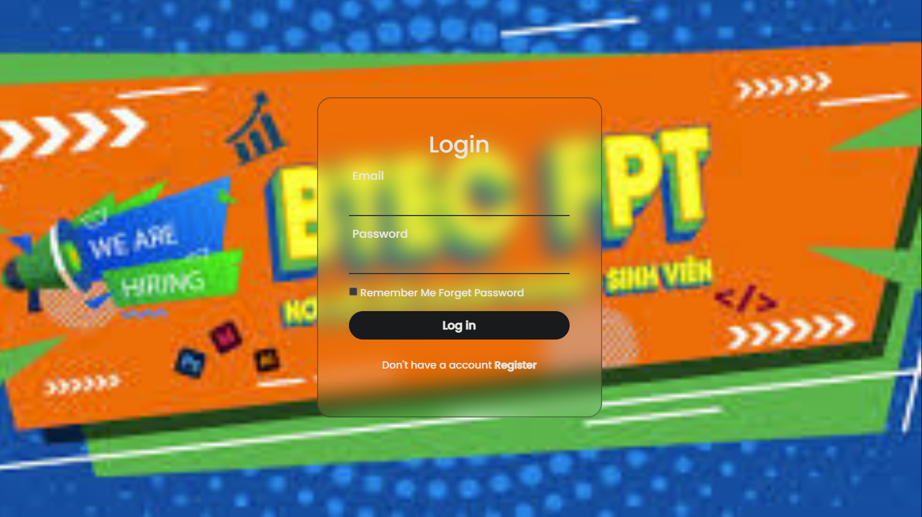

#### User Category management

* **Category Page**

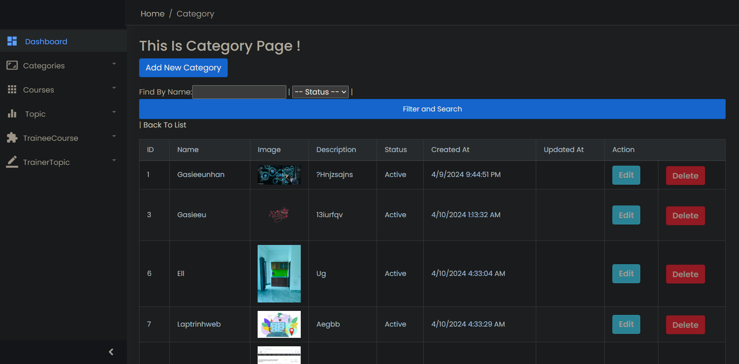

* **Add Category page**

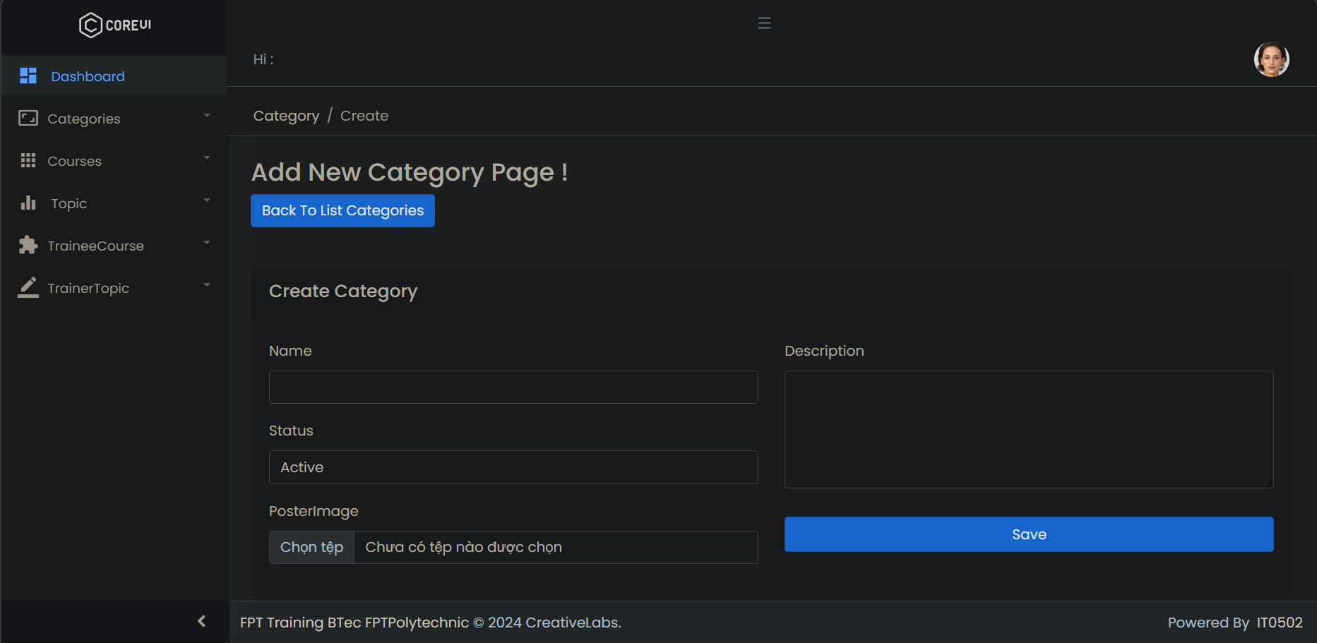

* **Update Category page**

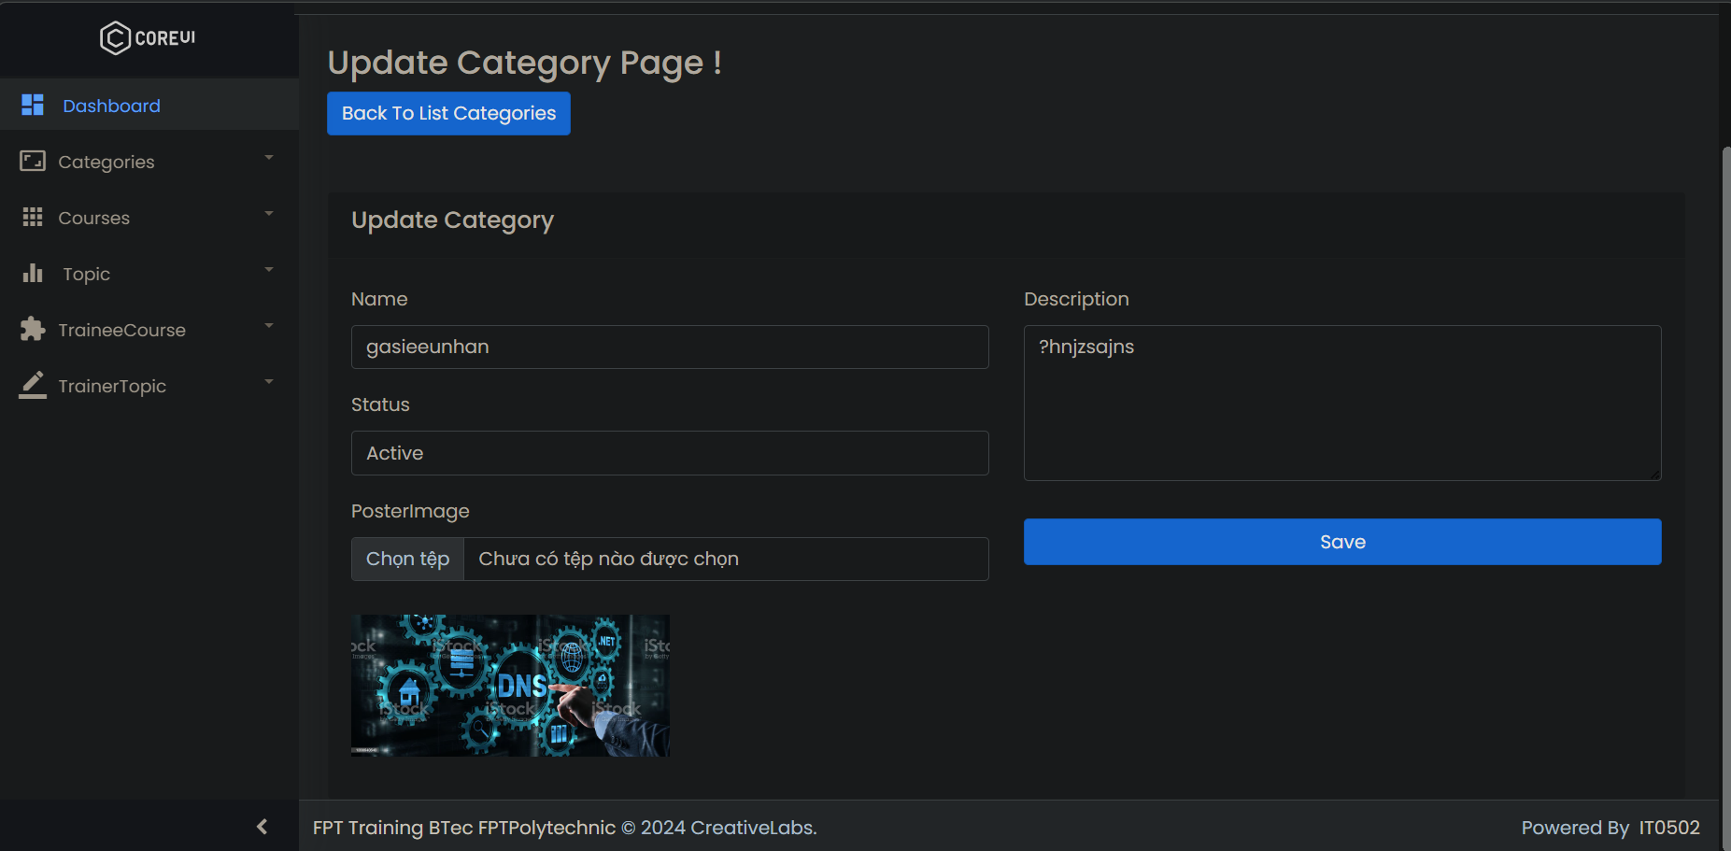

#### User Course management

* **Course manage page**

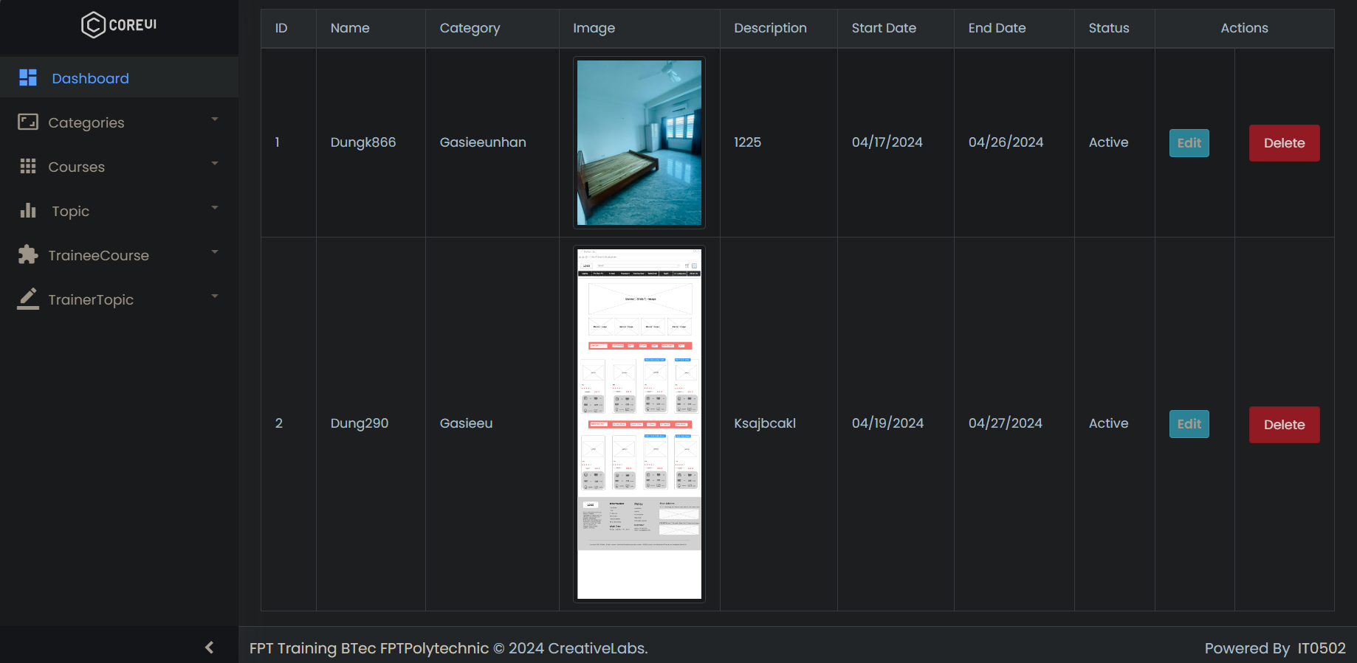

* **Add Courses page**

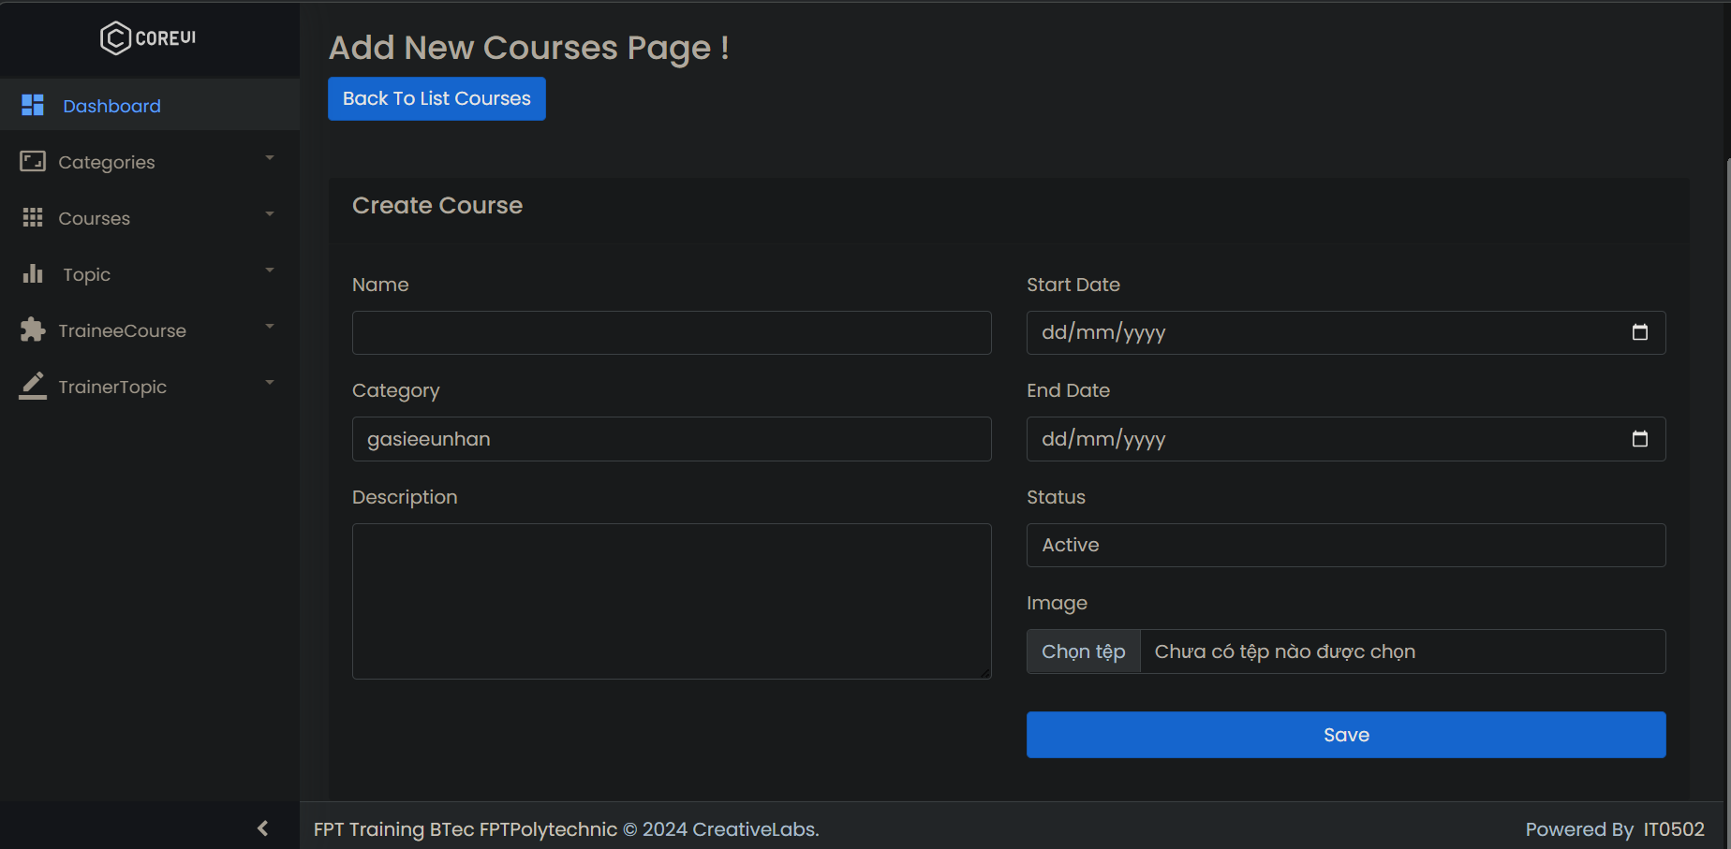

* **Update Courses page**

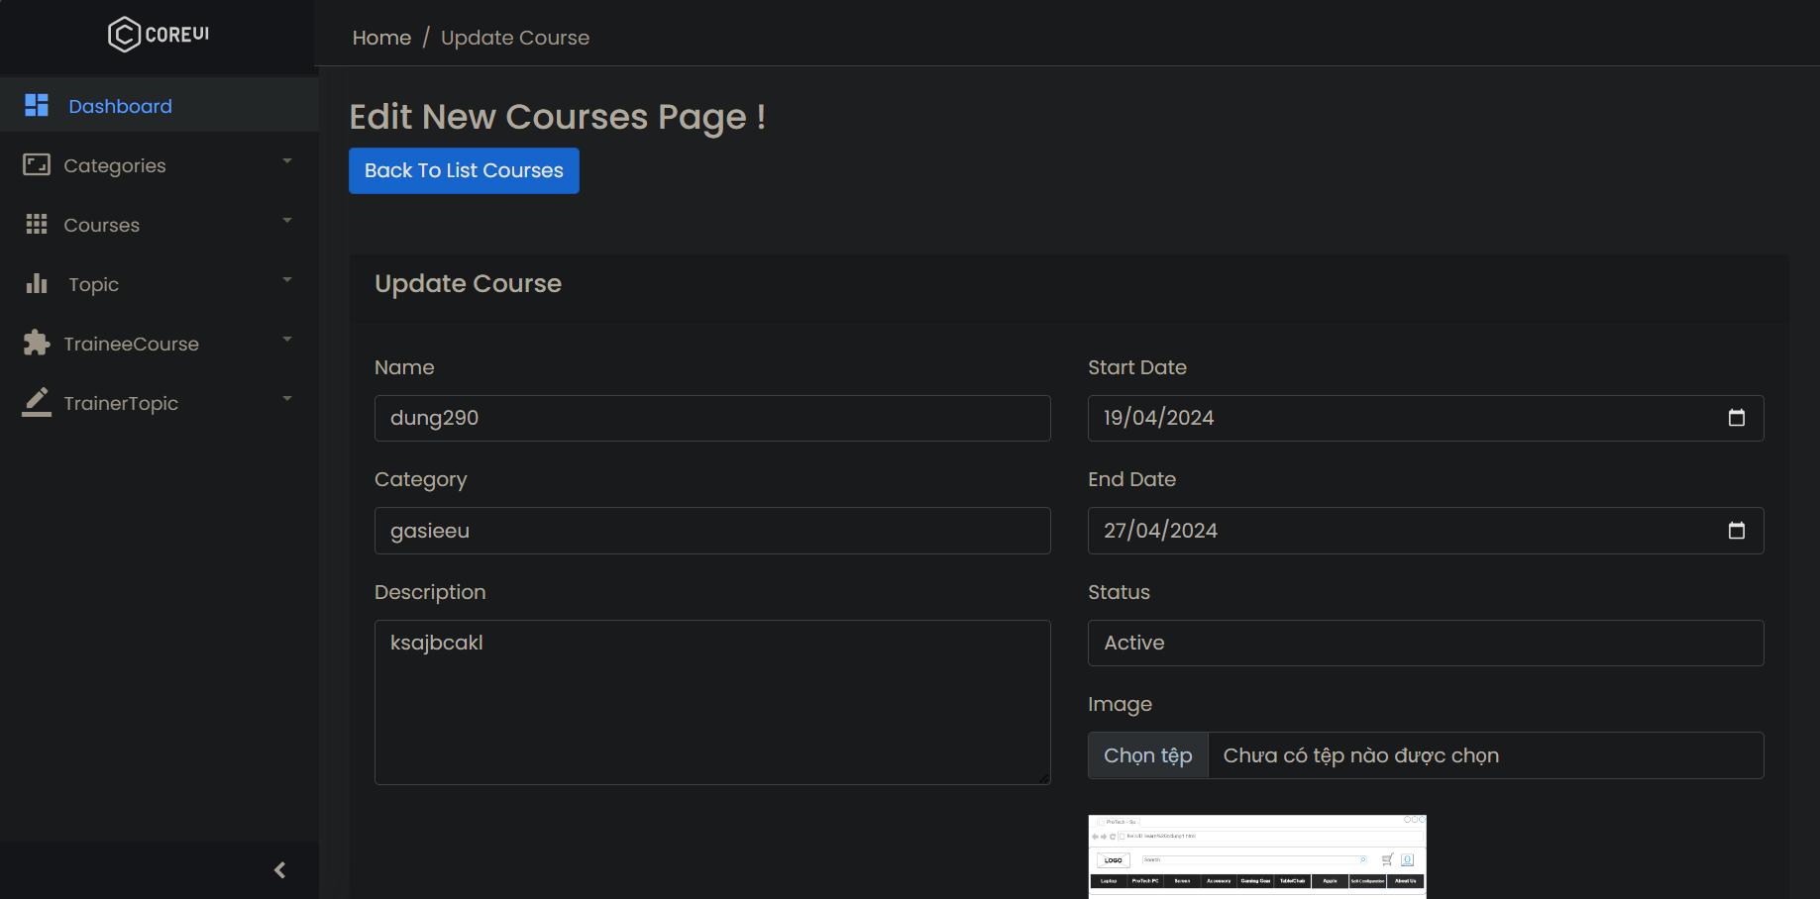

#### User topic management

* **Topic Manager page**

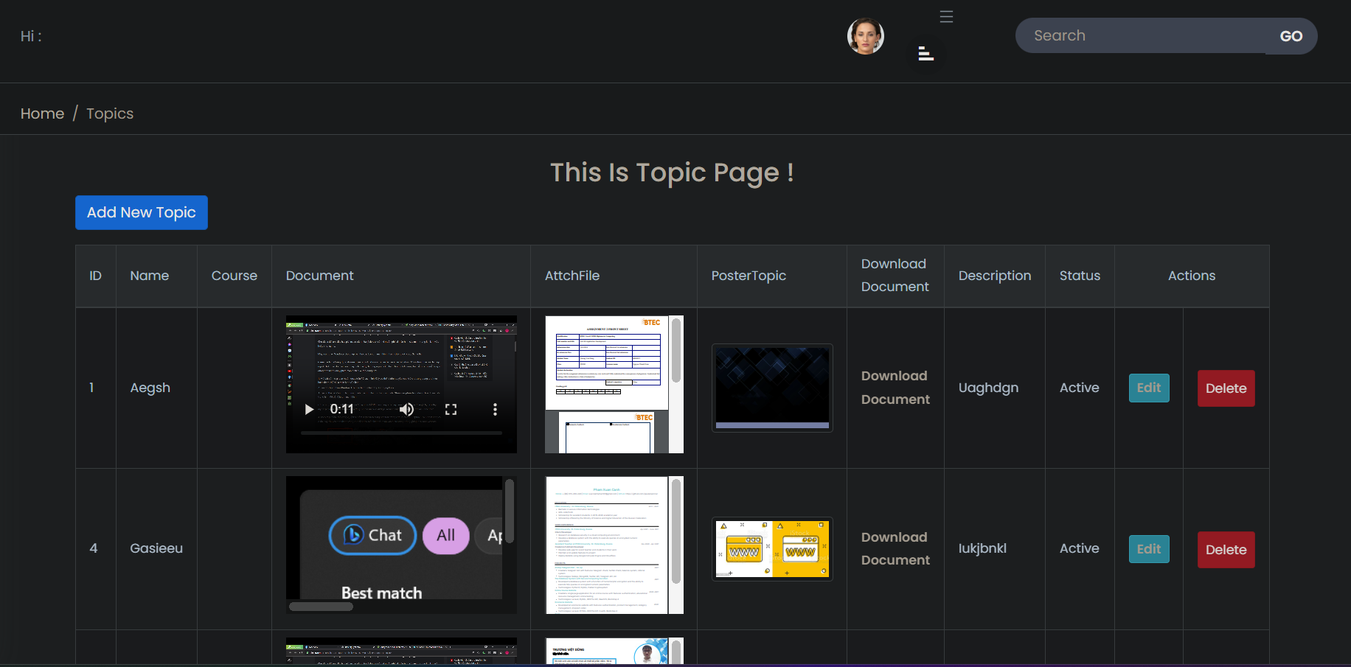

* **Create Topic page**

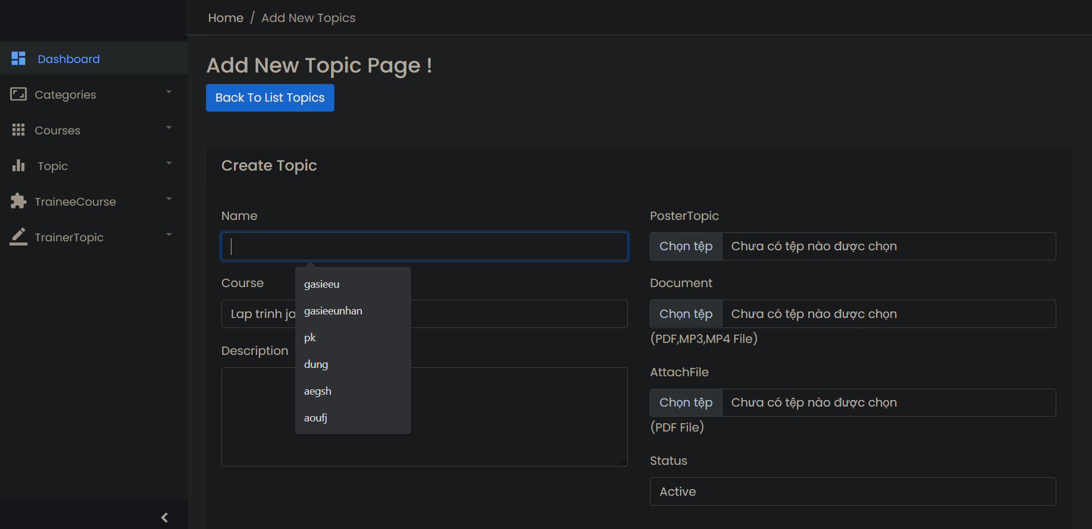

* **Update Topic page**

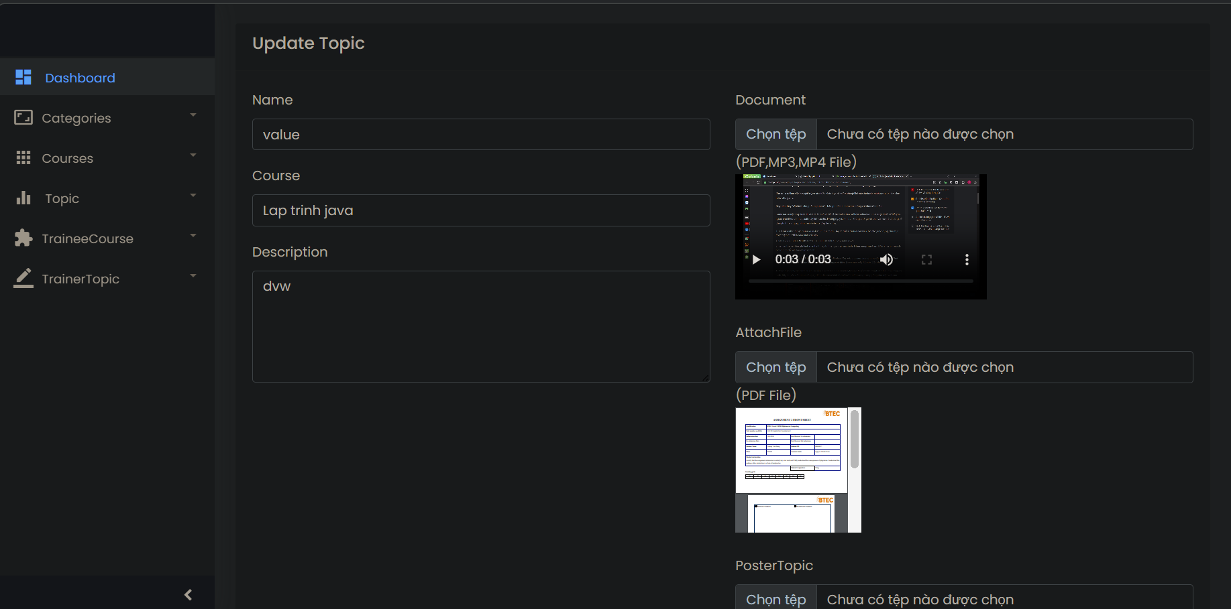

### 2.6. Functional System Requirements

#### 2.6.1. Administrator Functional Requirements

Login Capability:

• The system must facilitate administrator access via the application's initial page.

#### 2.6.2. Training Staff Functional Requirements

**Trainee Account Administration:**

• Generate trainee accounts by inputting details like name, account specifics, age, birth date, education, programming expertise, TOEIC score, experience particulars, department, and location.

• Record trainee account particulars in the system's database.

• Amend trainee account particulars.

• Remove trainee accounts.

**Trainee Oversight:**

• Review and locate trainee listings.

• Query trainees by account specifics, programming expertise, TOEIC score, etc.

**Course Category Oversight:**

• Explore, append, revise, and erase course categories.

• Each course category should encompass details like category title and descriptions.

**Course Oversight:**

• Explore, append, revise, and erase courses.

• Each course should entail particulars such as course title and description.

**Topic Oversight:**

• Incorporate topics into courses, specifying topic titles and descriptions.

**Trainer Profile Oversight:**

• Include, revise, and erase trainer profiles.

• Trainer profile details must cover trainer name, classification (external or internal), workplace, phone number, and email address.

**Assignment Oversight:**

• Allocate trainers to topics.

• Assign trainees to courses.

#### 2.6.3. Trainer Functional Requirements

**Profile Administration:**

• Modify trainer profile particulars, encompassing trainer name, classification (external or internal), educational background, workplace, telephone, and email address.

Course Reviewing:

• Peruse courses assigned to the trainer.

#### 2.6.4. Trainee Functional Requirements

**Trainee Profile:**

• Trainees must maintain individual profiles within the system, containing personal and academic particulars.

**Course Registration:**

• Trainees should possess the capability to register for accessible courses.

**Course Accessibility:**

• Trainees should be able to access enrolled courses and review associated topics.

#### 2.6.5. Comparative Analysis

Upon comparing the initially provided list with the requirements documented, several similarities and disparities emerge:

• Similarities: Both sets of requirements emphasize system login procedures, user account management, trainer oversight, and course management.

• Differences: The documented requirements delineate additional responsibilities for training staff and trainers, alongside more specified functionalities such as course category administration, topic assignment to courses, and trainer allocation to topics. Furthermore, the documented requirements introduce trainee profile management and offer more detailed insights into pertinent trainee fields.

## REVIEW THE PERFORMANCE OF YOUR BUSINESS APPLICATION AGAINST THE PROBLEM DEFINITION STATEMENT AND INITIAL REQUIREMENTS(P6).

### 3.1. Test Scenario

#### 3.1.1. Testing Strategy

* **Overview**

This testing strategy delineates the approach, extent, resources, and timetable for the development of an internal training management system. Evaluated functions encompass login, category administration, course oversight, and topic management.

* **Goals**

• Validate the operationality and user-friendliness of the internal training management system.

• Ensure seamless login functionality.

• Ascertain the precision and dependability of category, course, and topic administration functionalities.

• Recognize and rectify any system defects or anomalies.

* **Extent testing will encompass the following domains:**

Login Functionality

**Category Administration:**

|  |
| --- |
| • Addition of categories |
| • Modification of categories |
| • Deletion of categories |

**Course Oversight:**

|  |
| --- |
| • Addition of courses |
| • Modification of courses |
| • Deletion of courses |

**Topic Management:**

|  |
| --- |
| • Addition of topics |
| • Modification of topics |
| • Deletion of topics |

**Methodology**

Testing will involve a blend of manual and automated techniques. Test scenarios will be formulated to validate the functionality of each feature, encompassing boundary and exceptional cases. Both positive and negative testing scenarios will be considered.

**Timetable**

Testing will commence post-development completion and will persist until all detected issues are resolved. Estimated testing duration is two weeks.

**Resources**

Test Environment: Developmental setup with access to the internal training management system.

Test Data: Sample data for category, course, topic management, and login functionalities.

Test Scenarios Login Functionality Category Administration

• Validate the addition of a new category.

• Validate the modification of an existing category.

• Validate the deletion of a category.

**Course Oversight**

• Validate the addition of a new course.

• Validate the modification of an existing course.

• Validate the deletion of a course.

**Topic Management**

• Validate the addition of a new topic.

• Validate the modification of an existing topic.

• Validate the deletion of a topic.

**Exit Criteria**

- Resolution of all critical and high-priority defects.

- Test coverage for category, course, topic management, and login functionalities.

- System performance aligns with acceptable standards.

### 3.2. Test Case

|  |  |  |  |  |  |
| --- | --- | --- | --- | --- | --- |
| **No** | Test Case | Procedure | Expected Result | Actual Result | Evaluation |
| TC1 | Login Test | Step 1. Access <https://localhost:5000/> | Successfully logged in, Dashboard page displayed | Successfully logged in, Dashboard page displayed | Pass |
| TC2 | Login Test | Step 1. Access <https://localhost:5000/> | Login fails, login page displayed for re-entry | Login fails, login page displayed for re-entry | Pass |
| TC3 | Category Page | Select "Category" | Displays Category page | Displays Category page | Pass |
| TC4 | Add Category | Step 1. Click "Add Category" button | Displays a notice of successful addition | Displays a notice of successful addition | Pass |
| TC5 | Add Category | Step 1. Click "Add Category" button | Unable to add Category, prompt to enter Name | Unable to add Category, prompt to enter Name | Pass |
| TC6 | Edit Category | Step 1. Click "Edit" button | Displays a successful update message | Displays a successful update message | Pass |
| TC7 | Delete Category | Click "Delete" button | Displays a successful deletion message | Displays a successful deletion message | Pass |
| TC8 | Add Course | Step 1. Click "Add Course" button | Displays a notice of successful addition | Displays a notice of successful addition | Pass |
| TC9 | Add Course | Step 1. Click "Add Course" button | Unable to add Course, prompt to enter Start date | Unable to add Course, prompt to enter Start date | Pass |
| TC10 | Edit Course | Step 1. Click "Edit" button | Displays a successful update message | Displays a successful update message | Pass |
| TC11 | Delete Course | Click "Delete" button | Displays a successful deletion message | Displays a successful deletion message | Pass |
| TC12 | Add Topic | Step 1. Click "Add new Topic" button | Displays a notice of successful addition | Displays a notice of successful addition | Pass |
| TC13 | Add Topic | Step 1. Click "Add new Topic" button | Unable to add Topic, prompt to enter additional Document | Unable to add Topic, prompt to enter additional Video | Pass |
| TC14 | Edit Topic | Step 1. Click "Edit" button | Displays a successful update message | Displays a successful update message | Pass |
| TC15 | Delete Topic | Click "Delete" button | Displays a successful deletion message | Displays a successful deletion message | Pass |

# CONCLUSION

In conclusion, the development process of my business application has been a comprehensive journey encompassing design, implementation, and evaluation stages. By creating a formal questionnaire and seeking feedback from colleagues, I ensured that the application aligns with business goals and addresses identified problems effectively. The iterative process of reviewing, amending, and refining the design based on feedback has enhanced the robustness and suitability of the final solution. Throughout the development phase, adherence to the chosen technologies and methodology facilitated a systematic approach to building the application. Thorough testing and performance evaluation against the Software Requirement Specification ensured that the application meets functional and performance criteria. Reflecting on the strengths and weaknesses of the business application, I acknowledge areas of success such as efficient problem-solving and alignment with business objectives. However, challenges in scalability, integration, and user adoption highlight opportunities for improvement. Moving forward, addressing these challenges and leveraging insights gained from the development process will pave the way for further enhancement and refinement of the application, ultimately driving continuous improvement in employee development efforts.